Week 12

Progress Report – Sean Estrebillo

Tail Stock Inventor Drawing Finalization

The measurements for my part of the lathe model which is the tail stock have been fixed for it to be compatible with the other parts that other members of the group made and to be placed into the assembly file of the lathe model. Tail stock barrel and turning wheel have been added to the tail stock.

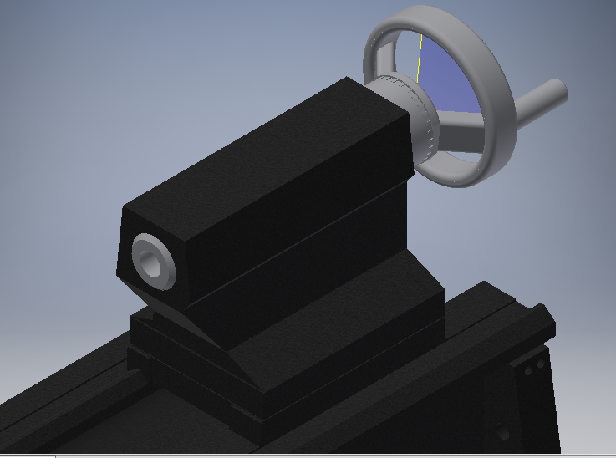

Ball Screw Inventor Drawing

Found a webpage that could help us add a ball screw and nut to our inventor assembly. This webpage allows us to download a 3d cad model of the selected ball screw nut that we needed, it made it easier for us and saved us time of doing it ourselves. Of course we’ll have to change it up just in case it doesn’t meet our needs but so far it was a good help for us.

Website link: <http://www.thkstore.com/bnt-nut.html>